**Base Query 1:**

|  |
| --- |
| **SELECT W_Location_D.Location_Id**  **,Location_Name**  **,W_Sales_Class_D.Sales_Class_Id**  **,Sales_Class_Desc**  **,Base_Price**  **,Time_Year**  **,Time_Month**  **,SUM(QUANTITY_ORDERED) AS Sum_Job_Qty**  **,SUM(QUANTITY_ORDERED * Unit_Price) AS Sum_Job_Amount**  **FROM W_JOB_F**  **,W_Location_D**  **,W_TIME_D**  **,W_Sales_Class_D**  **WHERE W_Location_D.Location_ID = W_Job_F.Location_Id**  **AND W_JOB_F.CONTRACT_DATE = W_TIME_D.Time_ID**  **AND W_Job_F.Sales_Class_Id = W_Sales_Class_D.Sales_Class_Id**  **GROUP BY W_Location_D.Location_Id**  **,Location_Name**  **,W_Sales_Class_D.Sales_Class_Id**  **,Sales_Class_Desc**  **,Base_Price**  **,Time_Year**  **,Time_Month;** |

**Screenshot 1:**

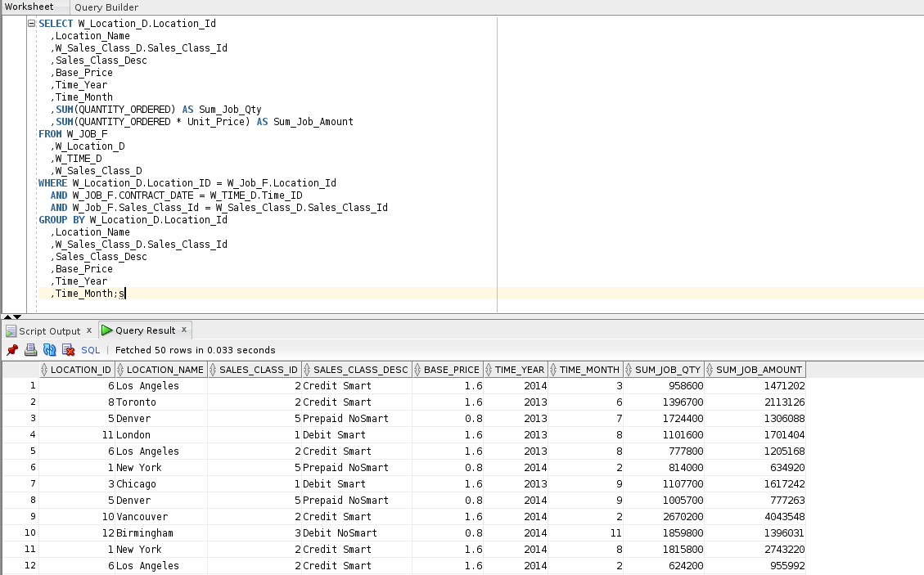

**Base Query 2:**

|  |
| --- |
| **SELECT W_Sub_Job_F.Job_Id**  **,W_Location_D.LOCATION_ID**  **,W_LOCATION_D.LOCATION_NAME**  **,Quantity_Ordered**  **,Unit_Price**  **,W_TIME_D.TIME_YEAR**  **,W_TIME_D.TIME_MONTH**  **,SUM(Invoice_Quantity) AS SumInvoiceQty**  **,SUM(Invoice_Amount) AS SumInvoiceAmt**  **FROM W_Job_Shipment_F**  **,W_Sub_Job_F**  **,W_Location_D**  **,W_Time_D**  **,W_InvoiceLine_F**  **,W_Job_F**  **WHERE W_Sub_Job_F.Sub_Job_Id = W_Job_Shipment_F.Sub_Job_Id**  **AND W_Job_Shipment_F.Invoice_Id = W_InvoiceLine_F.Invoice_Id**  **AND W_Time_D.Time_Id = Contract_Date**  **AND W_Location_D.Location_Id = W_InvoiceLine_F.Location_Id**  **AND W_Job_F.Job_Id = W_Sub_Job_F.Job_Id**  **GROUP BY W_Sub_Job_F.Job_Id**  **,W_Location_D.Location_Id**  **,W_LOCATION_D.LOCATION_NAME**  **,Quantity_Ordered**  **,Unit_Price**  **,W_Time_D.Time_Year**  **,W_Time_D.Time_Month;** |

**Screenshot 2:**

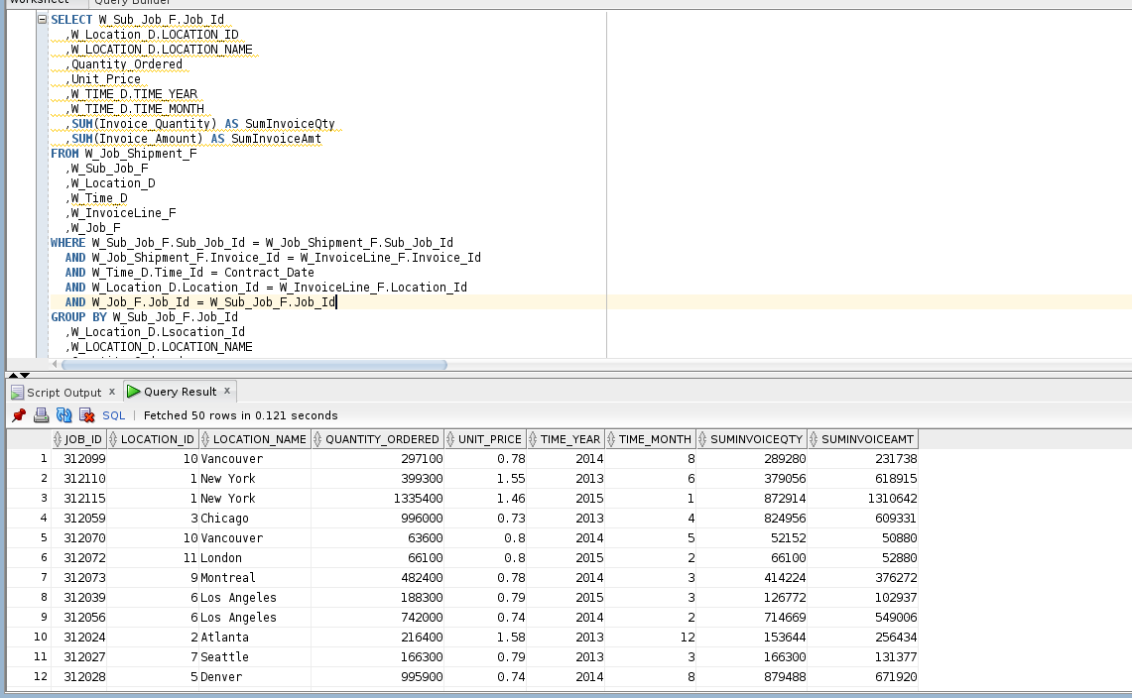

**Base Query 3:**

|  |
| --- |
| **CREATE VIEW LocRevenueSummary**  **AS**  **SELECT W_Sub_Job_F.Job_Id**  **,W_Location_D.LOCATION_ID**  **,W_LOCATION_D.LOCATION_NAME**  **,Quantity_Ordered**  **,Unit_Price**  **,W_TIME_D.TIME_YEAR**  **,W_TIME_D.TIME_MONTH**  **,SUM(Invoice_Quantity) AS SumInvoiceQty**  **,SUM(Invoice_Amount) AS SumInvoiceAmt**  **FROM W_Job_Shipment_F**  **,W_Sub_Job_F**  **,W_Location_D**  **,W_Time_D**  **,W_InvoiceLine_F**  **,W_Job_F**  **WHERE W_Sub_Job_F.Sub_Job_Id = W_Job_Shipment_F.Sub_Job_Id**  **AND W_Job_Shipment_F.Invoice_Id = W_InvoiceLine_F.Invoice_Id**  **AND W_Time_D.Time_Id = Contract_Date**  **AND W_Location_D.Location_Id = W_InvoiceLine_F.Location_Id**  **AND W_Job_F.Job_Id = W_Sub_Job_F.Job_Id**  **GROUP BY W_Sub_Job_F.Job_Id**  **,W_Location_D.Location_Id**  **,W_LOCATION_D.LOCATION_NAME**  **,Quantity_Ordered**  **,Unit_Price**  **,W_Time_D.Time_Year**  **,W_Time_D.Time_Month;** |

**Screenshot 3:**

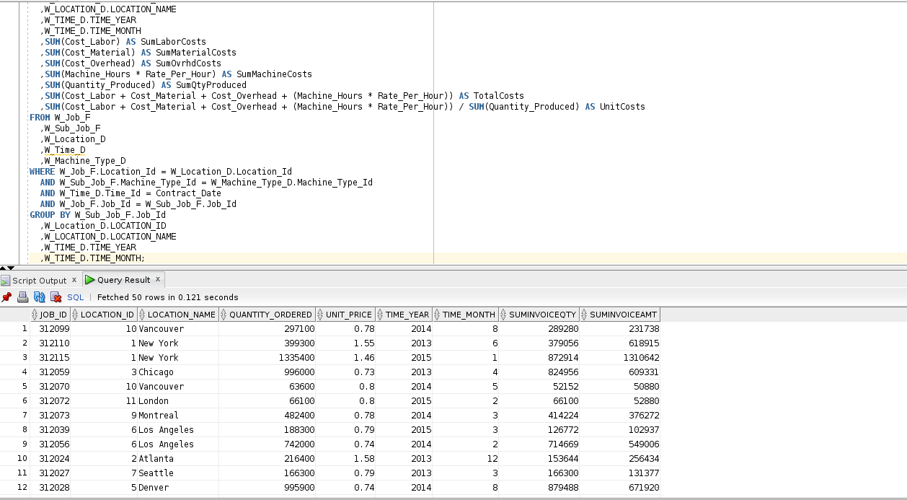

**Base Query 4:**

|  |
| --- |
| **SELECT W_Sub_Job_F.Job_Id**  **,W_Location_D.LOCATION_ID**  **,W_LOCATION_D.LOCATION_NAME**  **,W_TIME_D.TIME_YEAR**  **,W_TIME_D.TIME_MONTH**  **,SUM(Cost_Labor) AS SumLaborCosts**  **,SUM(Cost_Material) AS SumMaterialCosts**  **,SUM(Cost_Overhead) AS SumOvrhdCosts**  **,SUM(Machine_Hours * Rate_Per_Hour) AS SumMachineCosts**  **,SUM(Quantity_Produced) AS SumQtyProduced**  **,SUM(Cost_Labor + Cost_Material + Cost_Overhead + (Machine_Hours * Rate_Per_Hour)) AS TotalCosts**  **,SUM(Cost_Labor + Cost_Material + Cost_Overhead + (Machine_Hours * Rate_Per_Hour)) / SUM(Quantity_Produced) AS UnitCosts**  **FROM W_Job_F**  **,W_Sub_Job_F**  **,W_Location_D**  **,W_Time_D**  **,W_Machine_Type_D**  **WHERE W_Job_F.Location_Id = W_Location_D.Location_Id**  **AND W_Sub_Job_F.Machine_Type_Id = W_Machine_Type_D.Machine_Type_Id**  **AND W_Time_D.Time_Id = Contract_Date**  **AND W_Job_F.Job_Id = W_Sub_Job_F.Job_Id**  **GROUP BY W_Sub_Job_F.Job_Id**  **,W_Location_D.LOCATION_ID**  **,W_LOCATION_D.LOCATION_NAME**  **,W_TIME_D.TIME_YEAR**  **,W_TIME_D.TIME_MONTH;** |

**Screenshot 4:**

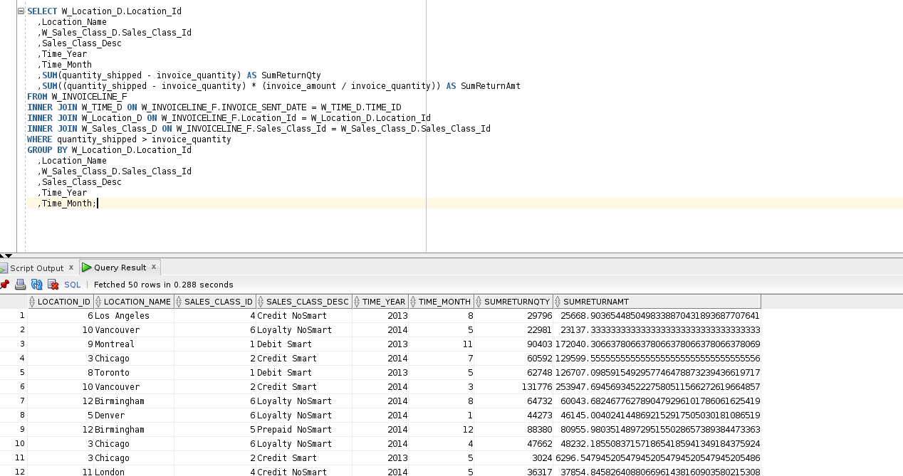

**Base Query 5:**

|  |
| --- |
| **CREATE VIEW LocCostSummary**  **AS**  **SELECT W_Sub_Job_F.Job_Id**  **,W_Location_D.LOCATION_ID**  **,W_LOCATION_D.LOCATION_NAME**  **,W_TIME_D.TIME_YEAR**  **,W_TIME_D.TIME_MONTH**  **,SUM(Cost_Labor) AS SumLaborCosts**  **,SUM(Cost_Material) AS SumMaterialCosts**  **,SUM(Cost_Overhead) AS SumOvrhdCosts**  **,SUM(Machine_Hours * Rate_Per_Hour) AS SumMachineCosts**  **,SUM(Quantity_Produced) AS SumQtyProduced**  **,SUM(Cost_Labor + Cost_Material + Cost_Overhead + (Machine_Hours * Rate_Per_Hour)) AS TotalCosts**  **,SUM(Cost_Labor + Cost_Material + Cost_Overhead + (Machine_Hours * Rate_Per_Hour)) / SUM(Quantity_Produced) AS UnitCosts**  **FROM W_Job_F**  **,W_Sub_Job_F**  **,W_Location_D**  **,W_Time_D**  **,W_Machine_Type_D**  **WHERE W_Job_F.Location_Id = W_Location_D.Location_Id**  **AND W_Sub_Job_F.Machine_Type_Id = W_Machine_Type_D.Machine_Type_Id**  **AND W_Time_D.Time_Id = Contract_Date**  **AND W_Job_F.Job_Id = W_Sub_Job_F.Job_Id**  **GROUP BY W_Sub_Job_F.Job_Id**  **,W_Location_D.LOCATION_ID**  **,W_LOCATION_D.LOCATION_NAME**  **,W_TIME_D.TIME_YEAR**  **,W_TIME_D.TIME_MONTH;** |

**Screenshot 5:**

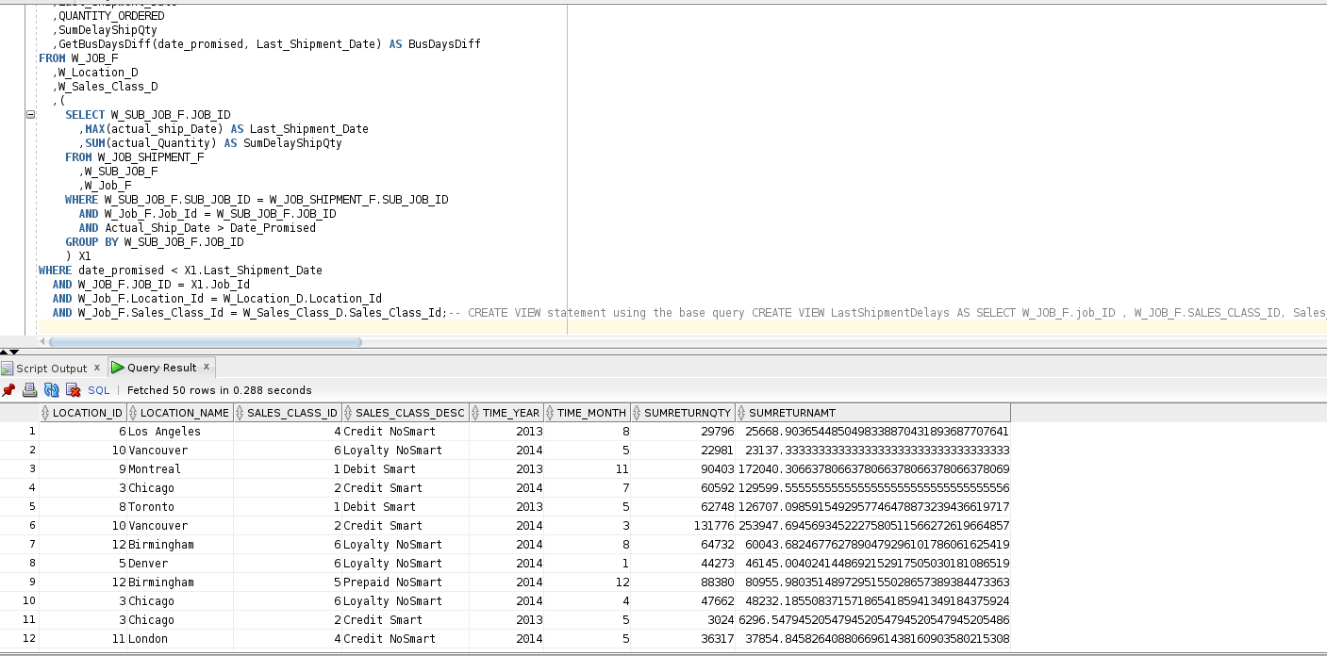

**Base Query 6:**

|  |
| --- |
| **SELECT W_Location_D.Location_Id**  **,Location_Name**  **,W_Sales_Class_D.Sales_Class_Id**  **,Sales_Class_Desc**  **,Time_Year**  **,Time_Month**  **,SUM(quantity_shipped - invoice_quantity) AS SumReturnQty**  **,SUM((quantity_shipped - invoice_quantity) * (invoice_amount / invoice_quantity)) AS SumReturnAmt**  **FROM W_INVOICELINE_F**  **INNER JOIN W_TIME_D ON W_INVOICELINE_F.INVOICE_SENT_DATE = W_TIME_D.TIME_ID**  **INNER JOIN W_Location_D ON W_INVOICELINE_F.Location_Id = W_Location_D.Location_Id**  **INNER JOIN W_Sales_Class_D ON W_INVOICELINE_F.Sales_Class_Id = W_Sales_Class_D.Sales_Class_Id**  **WHERE quantity_shipped > invoice_quantity**  **GROUP BY W_Location_D.Location_Id**  **,Location_Name**  **,W_Sales_Class_D.Sales_Class_Id**  **,Sales_Class_Desc**  **,Time_Year**  **,Time_Month;** |

**Screenshot 6:**

